Servizio Officina Meccanica

Coordinamento: Dr. Alessio Bosio
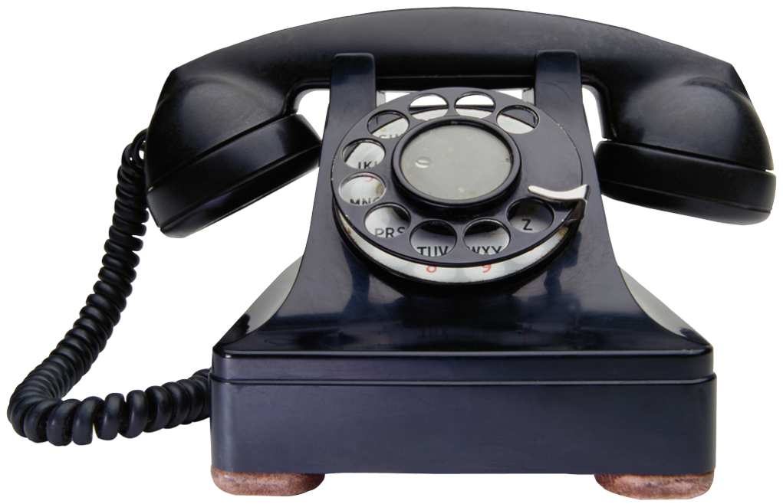 0521905257
@ alessio.bosio@unipr.it

Sezione tecnica: Sig. Michele Ronchini
0521905285 – 0521905286
@ michele.ronchini@unipr.it

Data ____________
Preventivo di Spesa

Breve descrizione:_________________________________________________________________
________________________________________________________________________________

Materiale Utilizzato: ______________________________ ________€
______________________________ ________€
______________________________ ________€
______________________________ ________€

Ore impegnate dal servizio: _______________ore ________€

TOTALE ________€

Per il Servizio
Sig. Michele Ronchini

_____________________________

Per accettazione
Il responsabile dei fondi

____________________________

